

**Design and Analysis of IoT**

**(SOFE 4610U)**

**Project Deliverables: Deployment Design Decisions**

Dr. Ramiro Liscano

Fall 2021

12/06/2021

Zainab Rehan - 100653955

Ramin Sami - 100655257

Jane Coralde - 100660214

Amin Khakpour - 100669547

# Deployment Design Decisions

Please visit [www.iotrashiot.xyz](http://www.iotrashiot.xyz) for the deployed domain.

For the deployment of the website and web application, we used Linux-Apache-MySQL-PHP (LAMP) which is open-source software that consists of Linux operating system, an Apache HTTP Server, a MySQL relational database management system, and the PHP programming language. We started with enabling the firewall on our instance. We set up a basic firewall using the application. Uncomplicated Firewall (UFW) is a program for managing a Netfilter firewall designed to be easy to use. It uses a command-line interface consisting of a small number of simple commands and uses iptables for configuration.

In the next step, we installed **Apache** which is free and open-source cross-platform web server software. We installed the apache with Ubuntu’s package manager.

For implementing the database we decided to use MySQL which was easy to install and the default configurations can work as far as we need for Ubuntu systems running the latest MySQL versions, the root user is authenticated using the auth_socket plugin by default instead of with a password.

Moving forward, we installed Hypertext Preprocessor (PHP), which is an open-source server-side scripting language for the development of web applications and services. Along with installing PHP, some more packages were installed that give the ability to run PHP code on the Apache web server and communicate with the MySQL database easily.

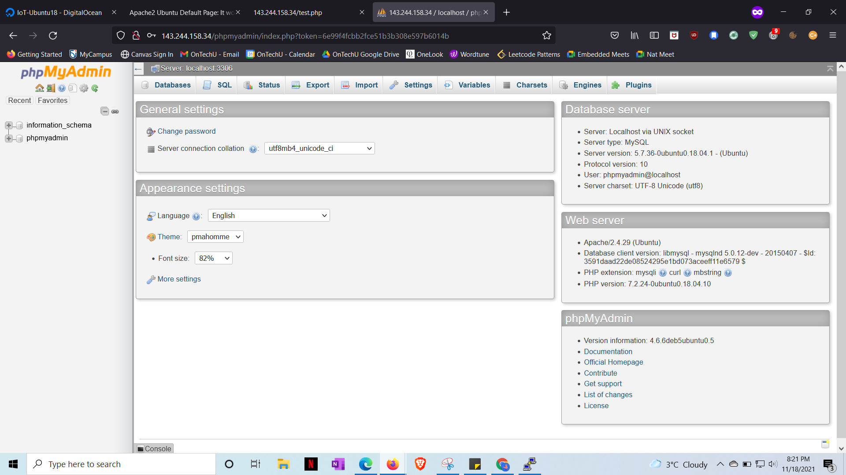

In this step, we are supposed to secure the instance and software, which leads us to use phpMyAdmin as an easy and efficient way to access MySQL functionality from the browser and at the same time maintain secure access. At this step, we had chosen a domain name to make it easier to connect to since many browsers do not understand SSL with IP addresses. iotrashiot.xyz is the domain we chose to move forward with. Now the domain name is configured and the relevant records have been updated on the control panel, we can progress to setting up SSL for our domain name. We need to have virtual hosts set up for Apache to use and configure our domain name effectively. The first step is to create a separate directory for our newly added domain.

Additionally installed the node package manager, NPM, which helps us update and add node packages to our instance as needed by leveraging JavaScript on both the front and back end. Node.js makes development more consistent and integrated.

In this interaction, we utilized Let's Encrypt, which is an endorsement authority (CA) that gives a simple and computerized method for acquiring, introducing, and keeping up with free TLS/SSL endorsements. This interaction is streamlined and computerized with the assistance of a product customer called Certbot. Certbot endeavors to computerize practically every one of the necessary advances and needs just minor manual exertion.



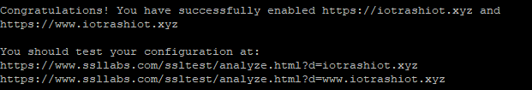

FileZilla let us to download a file from our cloud server, and then open, edit, and save it before uploading it back to the instance.

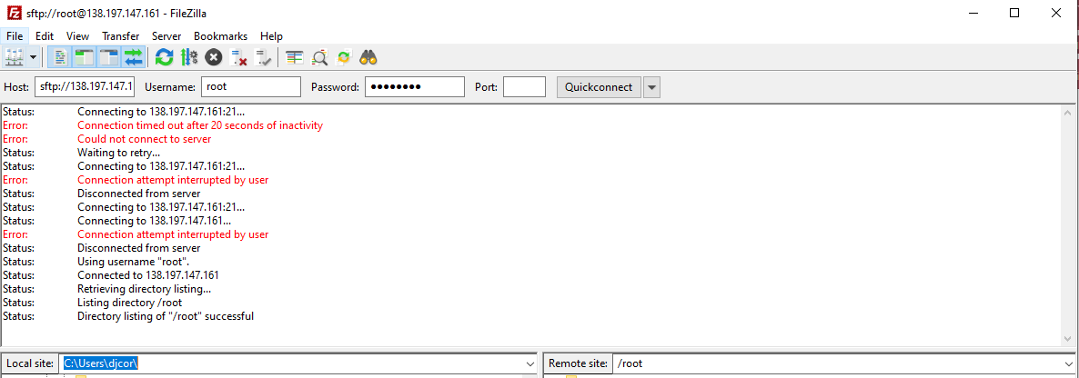

**Securing NodeRed**

We installed Node-RED as a global module so that it will add the node-red command to our cloud’s system path. Once we installed the node package manager, it was easier to install Node-RED with the same package manager. We will install Node-RED as a global module so that it will add the node-red command to our cloud’s system path.

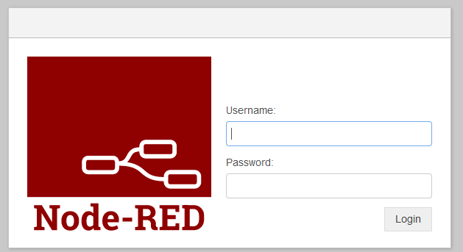

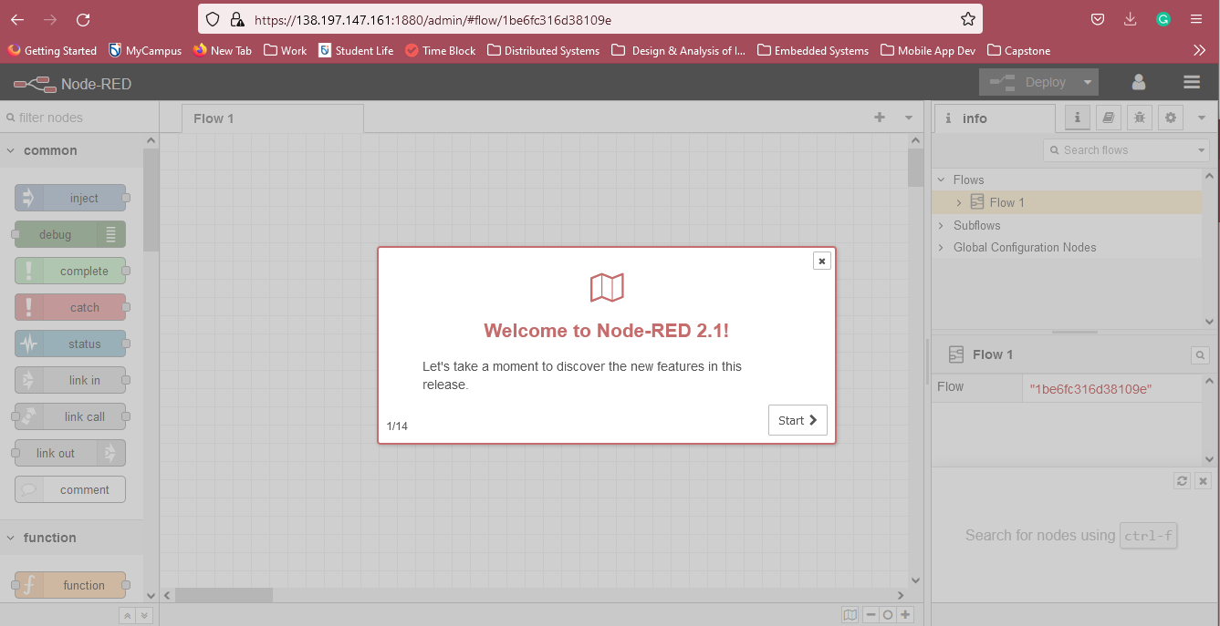

Faced errors with establishing connection with MQTT as the message broker. It is one of the

critical components, our team were not able to move forward with achieving the end-goal IoT platform.

Django is the framework that we used to integrate with the host to show the information.